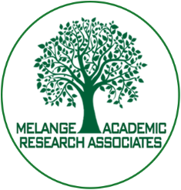
Conference on Social Science, Humanities and Management
CSHM - 2022
October 27th, 2022
SRM Hotel, Chennai, Tamil Nadu, India
Organized by
Melange Academic Research Associates, Puducherry, India

REGISTRATION FORM
- Name of the Author Registering for the Paper :
- Paper ID :
- Paper Title :
- Journal Name :
- Registration Details
UG/PG/PhD/Academicians/Industrialist :
Registration Fee :
Mode of Payment :
Payment Date :
- Accommodation Needed : Yes / No
- Email ID :
- Contact No. :
- Check list
- Camera Ready Copy : Yes / No
- Copyright Form : Yes/ No
- Proof of Payment : Yes / No

For further details
Contact Number:(+91)8903539101, Email: csshm2022@gmail.com, website:www.icaresm.com

